|  |  |  |  |  |  |  |  |  |
| --- | --- | --- | --- | --- | --- | --- | --- | --- |
| $$μ_{1}$$ | 0.5 | 0.5 | 0.5 | 0.5 | 0.5 | 0.5 | 0.5 | 0.5 |
| $$σ_{1}^{2}$$ | $$\frac{1}{12}$$ | $$\frac{1}{12}$$ | $$\frac{1}{12}$$ | $$\frac{1}{12}$$ | $$\frac{1}{12}$$ | $$\frac{1}{12}$$ | $$\frac{1}{12}$$ | $$\frac{1}{12}$$ |
|  | $$U\sim \left[0,1\right]$$ |  |  |  |  |  |  |  |
|  |  |  |  |  |  |  |  |  |
| $$μ_{2}$$ | 1 | 0.5 | 0.5 | 0.5 | 0.5 | 0.5 | 0.5 | 0.5 |
| $$σ_{2}^{2}$$ | $$\frac{1}{12}$$ | $$\frac{1}{12}$$ | $$\frac{1}{12}$$ | $$\frac{1}{12}$$ | $$\frac{1}{12}$$ | $$\frac{1}{12}$$ | $$\frac{1}{12}$$ | $$\frac{1}{12}$$ |
|  | $$U\sim \left[0.5,1.5\right]$$ | $$U\sim \left[0,1\right]$$ |  |  |  |  |  |  |

$D_{p}=0.5$**(analytically calculated)**

Dataset – Uniform Distribution

|  |  |
| --- | --- |
| Max Sample Size | $$D_{p} value given:$$ $$D_{p}=0.5$$ |
| 100 Points | 0.3801 (0.2444, 0.5159) |
| 500 Points | 0.4719 (0.3676, 0.5762) |
| 1000 Points | 0.5189 (0.3438, 0.6939) |

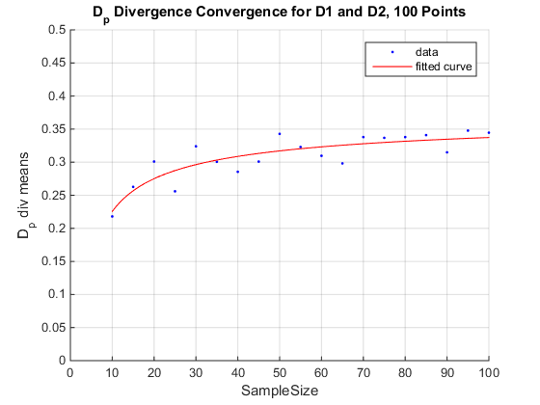

**(title should read 500)**

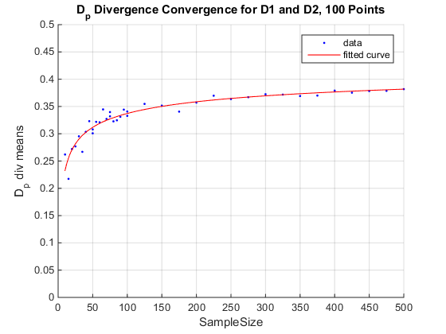

**(title should read 1000)**

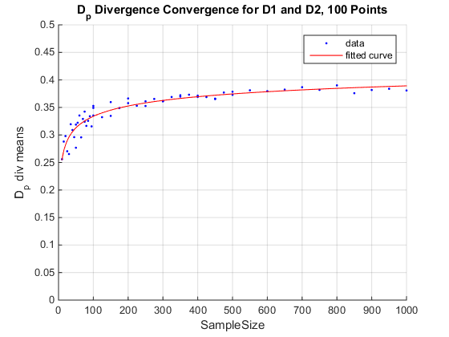

|  |  |  |  |  |  |  |  |  |
| --- | --- | --- | --- | --- | --- | --- | --- | --- |
| $$μ_{1}$$ | 0.5 | 0.5 | 0.5 | 0.5 | 0.5 | 0.5 | 0.5 | 0.5 |
| $$σ_{1}^{2}$$ | $$\frac{1}{12}$$ | $$\frac{1}{12}$$ | $$\frac{1}{12}$$ | $$\frac{1}{12}$$ | $$\frac{1}{12}$$ | $$\frac{1}{12}$$ | $$\frac{1}{12}$$ | $$\frac{1}{12}$$ |
|  | $$U\sim \left[0,1\right]$$ |  |  |  |  |  |  |  |
|  |  |  |  |  |  |  |  |  |
| $$μ_{2}$$ | 1.4 | 0.5 | 0.5 | 0.5 | 0.5 | 0.5 | 0.5 | 0.5 |
| $$σ_{2}^{2}$$ | $$\frac{1}{12}$$ | $$\frac{1}{12}$$ | $$\frac{1}{12}$$ | $$\frac{1}{12}$$ | $$\frac{1}{12}$$ | $$\frac{1}{12}$$ | $$\frac{1}{12}$$ | $$\frac{1}{12}$$ |
|  | $$U\sim \left[0.5,1.5\right]$$ | $$U\sim \left[0,1\right]$$ |  |  |  |  |  |  |

$D_{p}=0.9$**(analytically calculated)**

Dataset – Uniform Distribution

|  |  |
| --- | --- |
| Max Sample Size | $$D_{p} value given:$$ $$D_{p}=0.9$$ |
| 100 Points | 0.7508 (0.7309, 0.7707) |
| 500 Points | 0.8475 (0.8057, 0.8893) |
| 1000 Points | 0.8045 (0.7909, 0.818) |

**(100 points)**

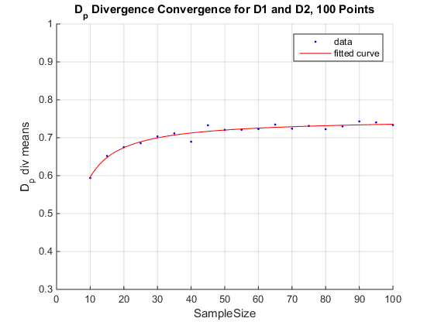

**(500 points)**

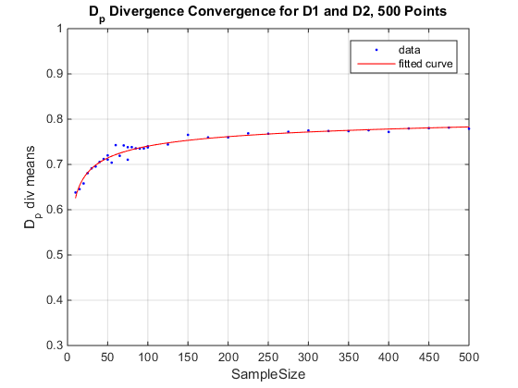

**(1000 points)**

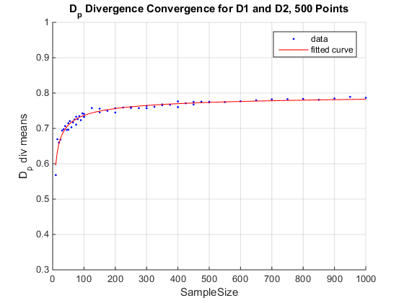

**Gaussian Datasets Given in Paper:**

Dataset 1 (Actual = 10 %)

|  |  |  |
| --- | --- | --- |
| Max Sample Size | E Bayes Upper Bound  (Calculated) | E Bayes Upper Bound  (Given in Paper) |
| 100 Points | 18.57% | 18.23% |
| 500 Points | 16.44% | 16.88% |
| 1000 Points | 13.08% | 16.46% |
| 1000 Points NEW | 15.16% | 16.46% |

|  |  |
| --- | --- |
| Max Sample Size | Dp_div value, 95% CI  (Calculated) |
| 100 Points | 0.6286 (0.6093, 0.648) |
| 500 Points | 0.6713 (0.6631, 0.6794) |
| 1000 Points *OLD | 0.7385 (0.6176, 0.8593) |
| 1000 Points *NEW | 0.6967 (0.6807,0.7128) |

Dataset 2 (Actual = 1.9 %) – May be inaccurate (dataset or given values)

|  |  |  |
| --- | --- | --- |
| Max Sample Size | E Bayes Upper Bound  (Calculated) | E Bayes Upper Bound  (Given in Paper) |
| 100 Points | 3.06% | 4.10% |
| 500 Points | 1.36% | 2.17% |
| 1000 Points | 1.21% | 1.94% |
| 1000 Points NEW | 0.91% | 1.94% |

|  |  |
| --- | --- |
| Max Sample Size | Dp_div value, 95% CI  (Calculated) |
| 100 Points | 0.9589 (0.944, 0.9738) |
| 500 Points | 0.9728 (0.9603, 0.9852) |
| 1000 Points | 0.9759 (0.9662, 0.9856) |
| 1000 Points NEW | 0.9817 (0.9794, 0.984) |

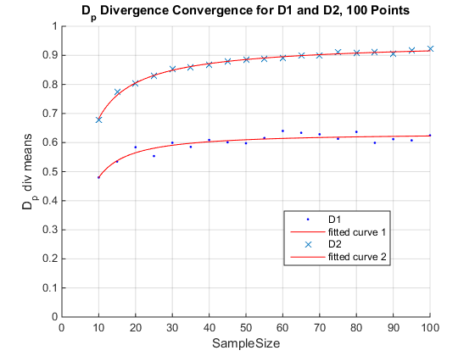OLD

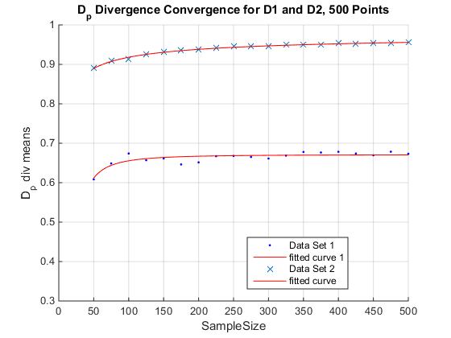OLD

(title should say 500 points)

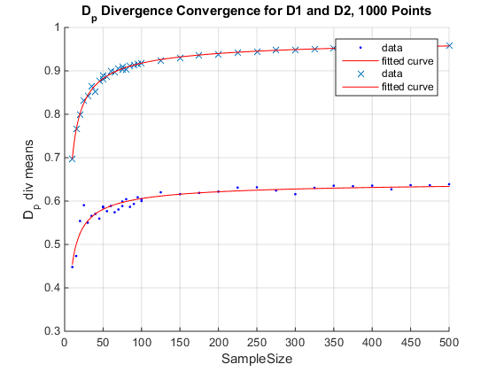NEW

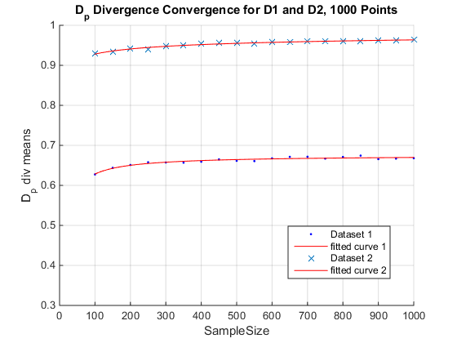OLD

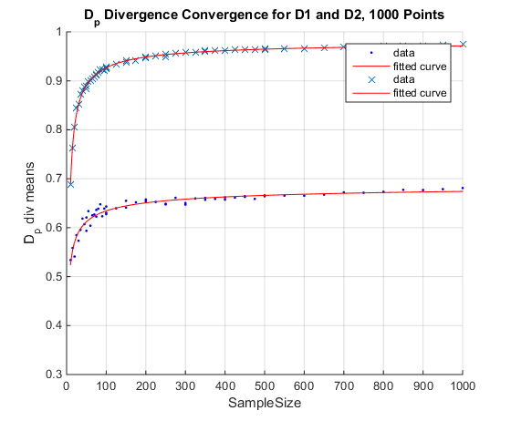NEW